Bumbling Bee finger puppet

Colour your bee and then cut it around the outline, including cutting carefully on the thick black line between the head and the wings.

If you want to colour the wings you’ll need to turn the bee over and colour the wings on the back.
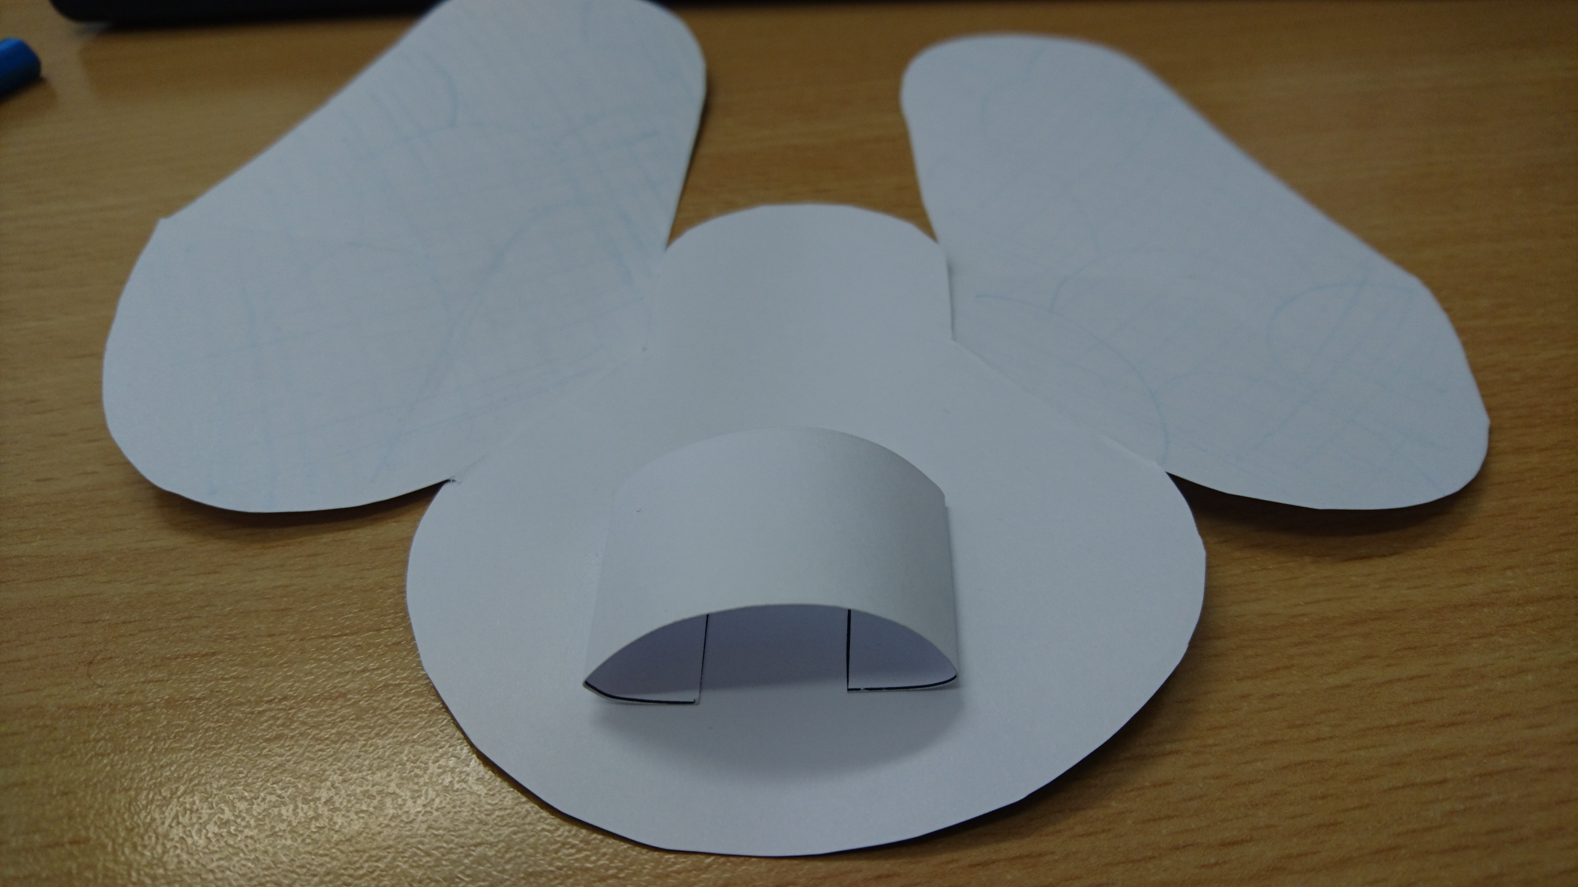
Cut out the finger loop and fold both ends over along the dotted lines, then glue these two ends to the back of the bee’s body, making a loop so that you can push one or two fingers through.

With the front of the bee facing you, cut along the thick black lines marked ‘A’ and ‘B’ and fold the wings back along the dotted line.

Turn the bee over and carefully slot the wings together so that the back of your bee looks like this:
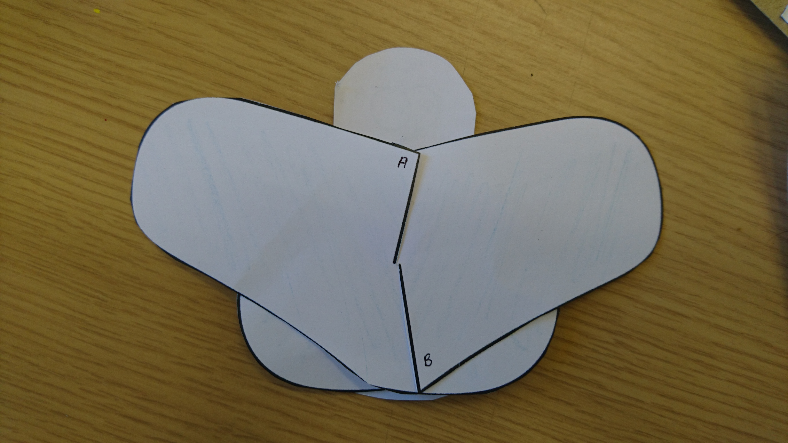

Cut out two of the black strips and glue them to the back of the bee’s head so that they stick up like antennae.

Cut out the remaining six black strips. Fold them all at one end two or three times so that they ‘zig-zag’, and then glue the other ends to the back of the body so that they stick out like legs.

Put one or two fingers into the loop inside the bee’s body and make very quick, small movements up and down – your bee’s wings will flutter as it happily bumbles around!

