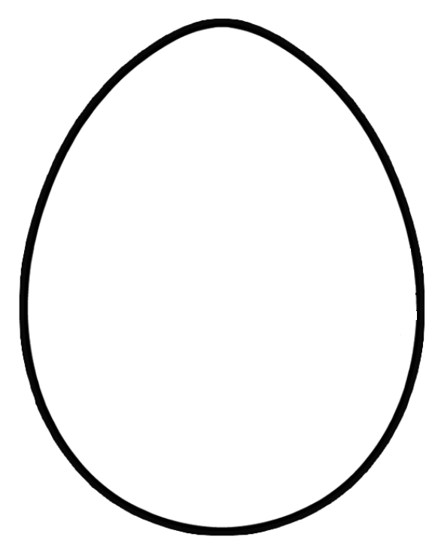
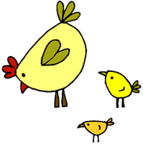
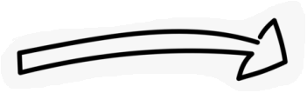
Happy Easter
Cut along the two dotted lines to remove this rectangle.
Cut inside the black line to remove this egg shape.

