Crawling Caterpillar

- Choose six strips of coloured paper - this works best if you choose 3 strips of one colour and 3 strips of another colour. You will also need a circle for the caterpillar’s face and two antennae.

- Glue 3 strips of one colour together, by the ends, to make a longer strip, attaching approximately 3cm overlap on each strip to keep them secure. Then repeat with the 3 strips of the other colour.
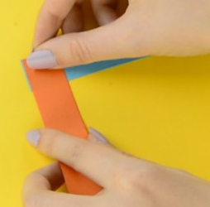
- Now glue one long strip on top of the other at a right angle, so that you make a giant ‘L’ shape.

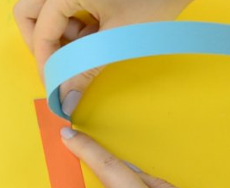
4. Fold the bottom strip over the top one (keeping the right angle) and crease the fold.

5. Again take the bottom strip (now the other colour) and fold it over the top one, still keeping the right angle.
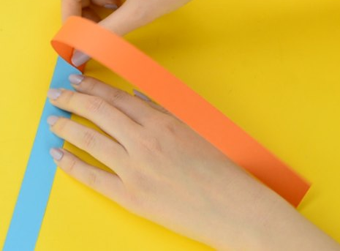

- Continue until you run out of strips to fold then glue the two end pieces together.

- Cut out the circle and draw a face on it.

- Cut out the two antennae and glue them to the back of the face so that they stick out at the top.

- Glue the back of the face onto one of the ends of the concertina body.

- Your caterpillar is now ready to crawl off to explore the garden!

