Group Booking Form 2015

Please read the relevant section of our groups visits brochure before completing this form. Confirmation of your visit and arrival details will be sent to you before your visit.
Name of Organisation:
Name of Group Leader (or tour company contact):
Address:

Telephone Number: Email:

Number in Group …….. Adults……. Children (5-16 yrs)……… Language Spoken……………………..
Date of Visit: …………… Time of arrival……………………. Approx time of departure…………………

Tea/Coffee on arrival required? Yes/No. This makes an excellent start to your group’s day out and is much more economical and time efficient than visitors paying individually. Please see overleaf for options and booking form.

HOW DID YOU HEAR ABOUT US? Please circle Advertising-Previous visit- Exhibition- Mail shot –Newsletter-Word of mouth

              
Please indicate your visit requirements below
Prices are based on a minimum of 15 people. (For groups of less than 15 the cost per person will increase accordingly.)
House and Gardens non-guided visit - £8.50 per adult. £5.00 per child.
Gardens only non-guided visit - £7.50 per adult. £4.50 per child.
Guided House Tour - £10.50 per adult. £5.50 per child. Between 9.30am -11.15am or at 4pm…………..
If you would like your tour to have a particular focus please circle. Portraiture, Art and its Politics,
Furniture, Needlework & Textiles, Medieval Life, Architecture, Porcelain and China, Behind the Scenes.
Guided Garden Tour - £10.50 per adult. £5.50 per child. Between 10.30 - 4.30pm……………………
Tea & Tour-add a cream tea to your House or Garden tour for £14.50 total per adult. Please see over.
Lunch & Tour-add a set hot lunch to your House or Garden tour for £22 total per adult. Please see over.
Combined House and Garden Tour - £17 per adult. £10.00 per child. Specify House Tour time between
9.30am -11am, or at 4pm…………Specify Garden Tour time between 10.30am - 4.30pm…………..
Head Gardener’s Tour - £10.50 per adult plus £70 per group. Dates and times subject to
availability – please contact Head of Visitor Services for more information.(unsuitable for children)
In the Footsteps of The Tudors Tour - Visit Penshurst Place & Hever Castle -£21.00 adult, £11.50 child.
Morning House Tour at Penshurst Place - Specify Tour time between 9.30am -11.15am…………
OR Morning Garden Tour at Penshurst Place - Specify Tour time between 9.30am -11.30am………..
Specify arrival time at Hever Castle for afternoon freeflow non-guided visit………………………
‘Winter Behind the Scenes’ Tour-£15.50 per adult including seasonal refreshments. Please call for details.
Payment By Cash, cheque or credit card on arrival (Cheques payable to Penshurst Place) Invoice (tour operators only)
TRANSPORT – Arriving by: Y/N Double Decker Bus Y/N Single Decker Bus Y/N Individual cars
WHEELCHAIR USERS YES NO If yes, please state number of visitors using wheelchairs……………………
Please note that some of the paths are uneven in places so we ask that wheelchair users bring a relatively fit and able bodied companion to assist them. We have 2 wheelchairs available to hire, please telephone to book.

HOW DID YOU HEAR ABOUT US – Advertising Previous visit Exhibition Mail shot Word of mouth

Group Catering Booking Form 2015

THE FOLLOWING PRICES ARE FOR GROUP BOOKINGS OF A MINIMUM OF 15 AND MAXIMUM OF 50 PEOPLE IN THE GARDEN RESTAURANT DURING OUR OPEN SEASON. FOR GROUPS OF OVER 50 PLEASE CONTACT US TO DISCUSS YOUR REQUIREMENTS. To assist you please read page 8-9 of the Group Booking Information brochure before completing.

Yes/No Do your group require lunch on an individual basis, without booking as a group. How many?.............

Please complete the form below if you wish to pre-book for your group, adding the numbers required.
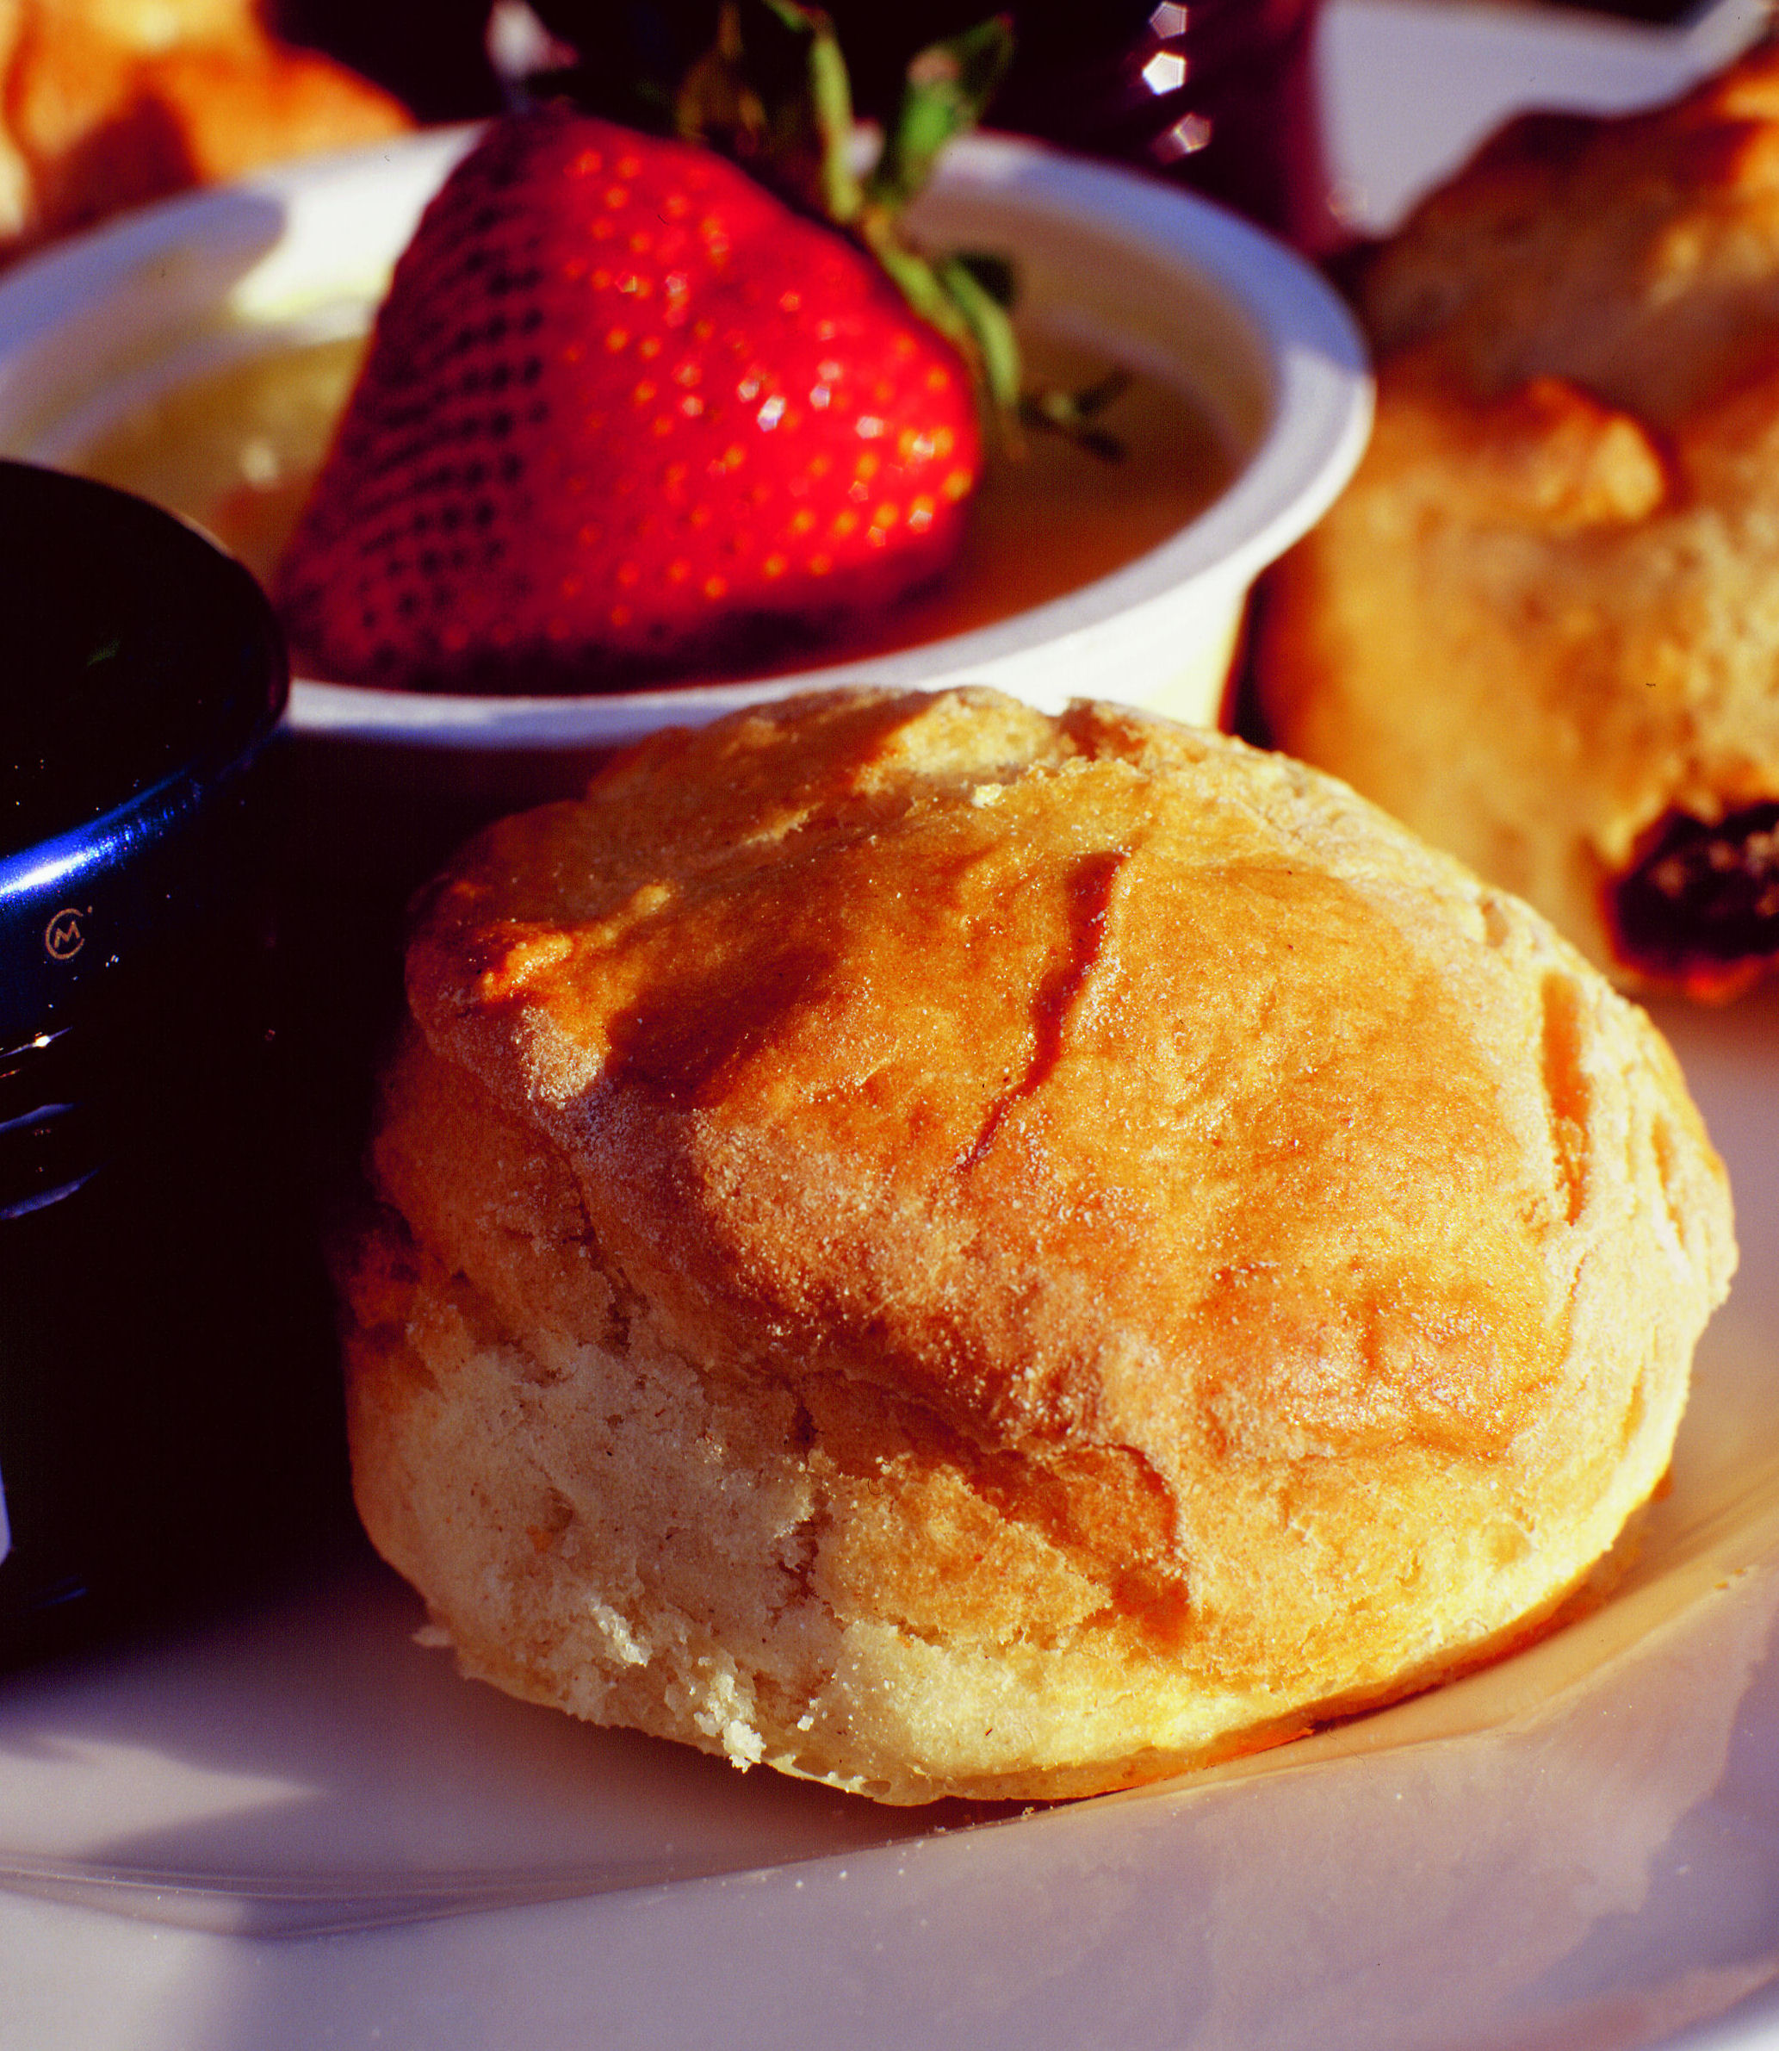
Morning Coffee Time required………… number.…… (served between 10.30-11.30am)

Coffee/Tea with a freshly baked cookie…. £2.95 pp; Danish Pastry…. £4.50pp; Bacon Roll…. £5.75pp

Lunch Time required …………(between 12 and 2.30pm) Includes table service. Number ……….

£14.95 per person
(Please choose one option for your whole group, except for vegetarians.)
Chicken Breast in a Creamy Mushroom & Chive Sauce, Roast New Potatoes, Seasonal Vegetables……
OR Steak, Mushroom & Local Ale Pie, Mashed Potatoes & Seasonal Vegetables……….
OR Leek and Stilton Tart served with a Butter Sauce & Mixed Leaves (V)…………

Penshurst Mess (raspberries with meringue and cream)………
OR Sticky Toffee Pudding with Toffee Sauce & Vanilla Ice Cream………
OR Penshurst Orchard Apple & Blackberry Crumble with Custard ……..
and Tea or Coffee

£16.50 p.p. if a starter added – Seasonal Soup & Roll……or Goat’s Cheese & Tomato Tartlet………
Lighter options, such as sandwich platters, are available on request. Please don’t hesitate to contact our Garden Restaurant Manager directly on 01892 871052 who will be pleased to assist you.

Afternoon Tea Time required………..(after 3.00pm) Includes table service. Number……..

TRADITIONAL CREAM TEA - £5.50 per person
2 fruit scones with clotted cream & jam, pot of tea/coffee
OR
PENSHURST HIGH TEA - £9.95 per person
Freshly made finger sandwiches, Lady De L’Isle’s apple cake,
a fruit scone with clotted cream & jam. Served with a pot of Tea or Coffee

All menus are subject to availability. Full menus are available daily from the Garden Restaurant. Some of the foods on our menus may contain nuts and other allergens.
Please return this form to: Head of Visitor Services
Penshurst Place & Gardens, Penshurst, Tonbridge, Kent Tn11 8dg | Tel: 01892 870307 | Fax: 01892 870866 Email: wendyw@penshurstplace.com | Website: www.penshurstplace.com

