Group Booking Form 2018
please note that a final Confirmation of your visit will be sent to you 3 weeks before your visit.
Name of Organisation:
Name of Group Leader (or tour company contact):
Address:

Telephone Number: Email: Group leader mobile:
Number in Group …….. Adults……. Children (5-16 yrs)……… Language Spoken……………………..
Date of Visit: …………….. Time of arrival……………………. Approx time of departure……………

Tea/Coffee on arrival required? Yes/No. This makes an excellent start to your group’s day out and is more economical and time efficient than visitors paying individually. Please see overleaf for options and booking form.

WHEELCHAIR USERS? YES/NO How many …… This is vital information for us to have, especially for guided tours. Please note that there is a 10 minute walk from the coach park to the House entrance. Most of the paths are not paved and uneven in places, so we ask that all wheelchair users bring a fit and able bodied companion to assist them. We have 2 wheelchairs available to hire. Alternative drop off arrangements possible.
           
Please indicate your visit requirements below
Prices are based on a minimum of 15 people. (For groups of less than 15 the cost per person will increase accordingly.)
House & Gardens non-guided visit -£9.00 adult. £5.00 child. Gardens only £8.00adult £4.50child.
Guided House Tour - £11.00 per adult. £5.50 per child. Between 9.30am -11.15am or at 4pm…………..
If you would like your tour to have a particular focus please circle. Portraiture, Art and its Politics,
Furniture, Needlework & Textiles, Medieval Life, Architecture, Porcelain and China, Behind the Scenes.
Guided Garden Tour - £11.00 per adult. £5.50 per child. Between 10.30 - 4.30pm……………………
Tea & Tour-add a cream tea to your House or Garden tour for £15.50 total per adult. Please see over.
Lunch & Tour-add a set hot lunch to your House or Garden tour for £23.00 total per adult. See over.
Combined House and Garden Tour - £18.00 per adult. £10 per child. Specify House Tour time between
9.30am -11am, or at 4pm………. .Specify Garden Tour time between 10.30am - 4.30pm…………..
Combined House and Village Church Tour - £18.00 per adult. Specify House Tour time between
9.30am -11am, or at 4pm………. .Specify Church Tour time between 10.30am - 4.30pm…………..
Head Gardener’s Tour - £11.00 per adult plus £70 per group. Dates and times subject to
availability – please contact Head of Visitor Services for more information.(unsuitable for children)
Connoisseur’s Tour - £19.00 per adult. (Special Interest House & Church tour) Please call for details.
In the Footsteps of The Tudors Tour - Visit Penshurst Place & Hever Castle - £22.50 adult.
Morning House Tour at Penshurst Place - Specify Tour time between 9.30am -11.15am…………
OR Morning Garden Tour at Penshurst Place - Specify Tour time between 9.30am -11.30am………..
Specify arrival time at Hever Castle for afternoon freeflow non-guided visit………………………
‘Winter Behind the Scenes’ Tour-£16.00 per adult including seasonal refreshments. Please call for details.
Payment By Cash, cheque or credit card on arrival (Cheques payable to Penshurst Place) Invoice (tour operators only)
TRANSPORT – arriving by: Double Decker Bus Single Decker Bus Individual cars (please circle)

HOW DID YOU HEAR ABOUT US? Please circle Advertising-Previous visit- Exhibition- Mail shot –Newsletter-Word of mouth

HOW DID YOU HEAR ABOUT US – Advertising Previous visit Exhibition Mail shot Word of mouth

Group Catering Booking ForM – SPRING/SUMMER 2018

THE FOLLOWING PRICES ARE FOR GROUP BOOKINGS OF A MINIMUM OF 15 AND MAXIMUM OF 50 PEOPLE IN THE GARDEN RESTAURANT DURING OUR OPEN SEASON. FOR GROUPS OF OVER 50 PLEASE CONTACT US TO DISCUSS YOUR REQUIREMENTS.

Yes/No Do your group require lunch on an individual basis, without booking as a group. How many?.............

Please complete the form below if you wish to pre-book for your group, adding the numbers required.
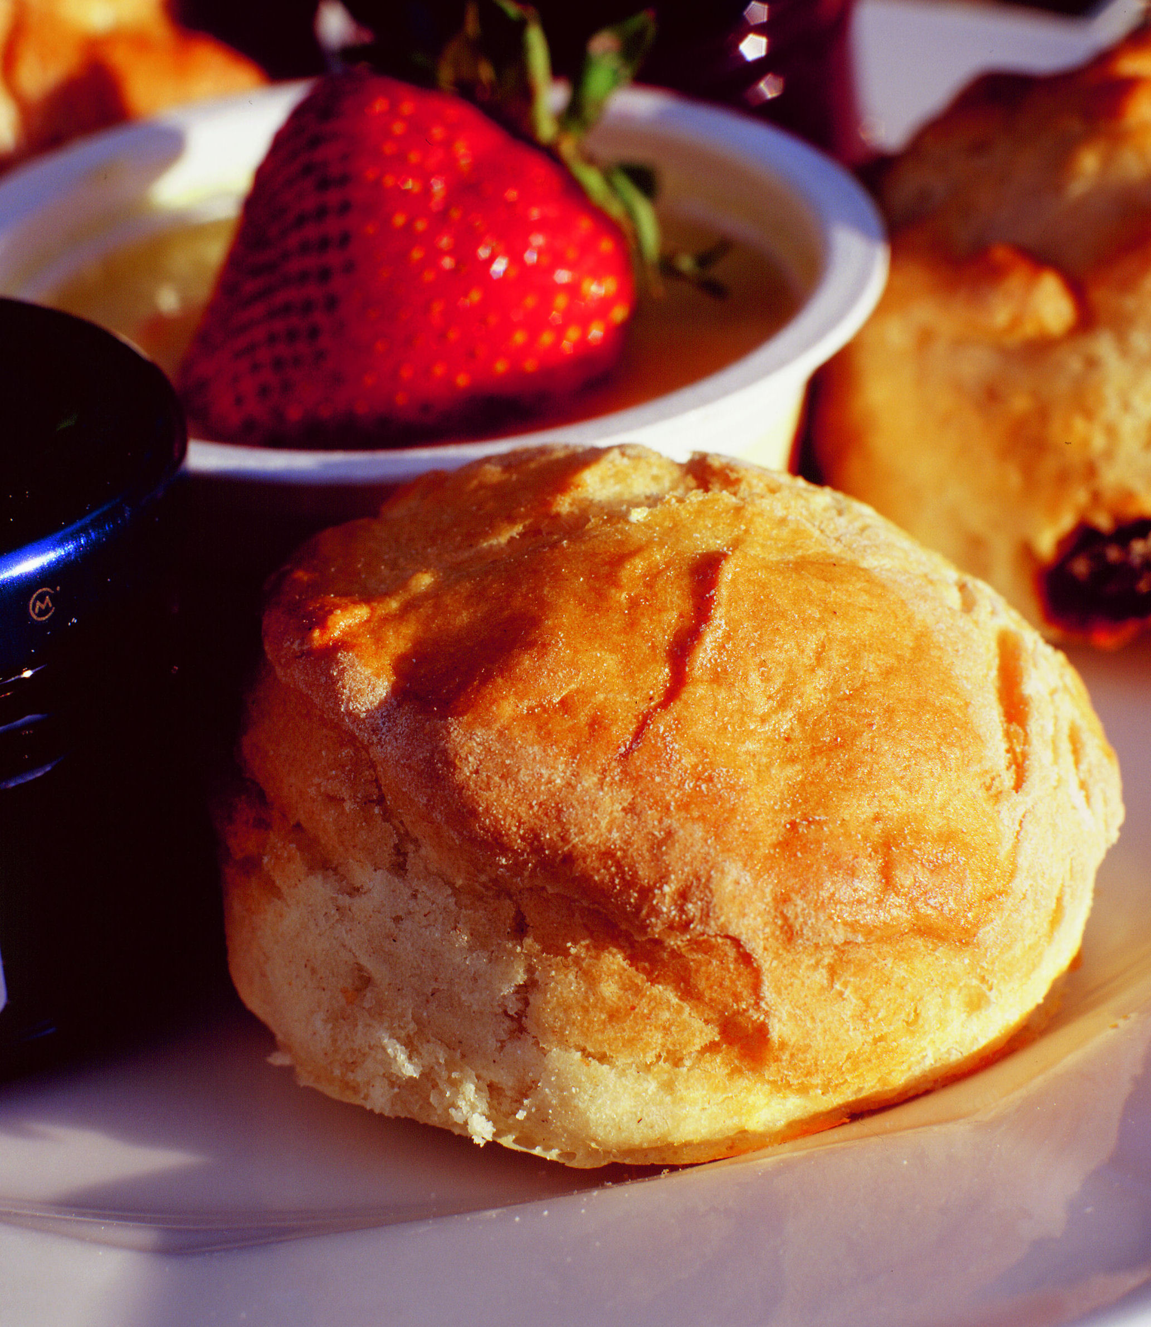
Morning Coffee Time required………… number.…… (served between 10.30-11.30am)

Coffee/Tea with a freshly baked cookie…. £3.75pp; Danish Pastry…. £4.50pp; Bacon Roll…. £5.75pp

Lunch Time required …………(between 12 and 2.30pm) Includes table service.
Number required ………. Two course lunch @ £14.95 or a three course lunch @ £17.50.
(Please choose one option for your whole group, except for vegetarians. Includes tea or coffee.)

STARTERS (choose one)
Daily homemade vegetable soup with artisan bread & butter
Salad of Kentish beetroot, home farm goats’ cheese curd, peas & yogurt dressing
Smoked mackerel pate with crisp Penshurst apple & celeriac salad

MAIN COURSES (choose one)
Seared breast of chicken with young spinach, broad beans & a puff pastry case
Baked fillet of hake with white beans, young courgettes, olives and tomato stew
Tartelette of Kentish blue cheese with soft herbs & warm potato salad
Braised pork, Kentish apple & cider pie

DESSERTS (choose one)
Set vanilla cream with local berries & minted sugar
Seasonal fruit Penshurst Mess (berries with meringue & cream
Orchard apple cake with clotted cream
Glass of wine: £4.95 Fruit Juice: £1.50 Lager: £4.50. Soft drink: £2.00

Lighter options, such as soup and sandwich platters, are also available. Please don’t hesitate to contact our Garden Restaurant Manager directly on 01892 871684 who will be pleased to assist you.

Afternoon Tea Time required………..(after 3.00pm) Includes table service. Number……..

THE SECOND VISCOUNT – a traditional cream tea - £5.50
Two fruit scones with strawberry preserve & clotted cream served with a pot of tea or coffee

THE SIR WILLIAM SIDNEY - a delicious traditional high tea - £14.95
Finger sandwiches – cucumber & mint/ham & tomato/egg mayonnaise/smoked salmon
Selection of homemade cakes
Fruit scones with strawberry preserve & clotted cream served with a pot of tea or coffee

All menus are subject to availability. Full menus are available daily from the Garden Restaurant. Some of the foods on our menus may contain nuts and other allergens.
Please return this form to: Head of Visitor Services
Penshurst Place & Gardens, Penshurst, Tonbridge, Kent Tn11 8dg | Tel: 01892 870307 | Fax: 01892 870866 Email: wendyw@penshurstplace.com | Website: www.penshurstplace.com

