Group Booking Form 2014

Please read the relevant section of our groups visits brochure before completing this form. Confirmation of your visit and arrival details will be sent to you before your visit.
Name of Organisation:
Name of Group Leader (or tour company contact):
Address:

Telephone Number: Email:

Number in Group …….. Adults……. Children (5-16 yrs)……… Language Spoken……………………..
Date of Visit: …………… Time of arrival……………………. Approx time of departure…………………

Tea/Coffee on arrival required? Yes/No. Please see overleaf for group catering options and booking form.

HOW DID YOU HEAR ABOUT US? Please circle Advertising-Previous visit- Exhibition- Mail shot –Newsletter-Word of mouth

              Other: ..........................................................................................................................

Please indicate your visit requirements below
Prices are based on a minimum of 15 people. (For groups of less than 15 the cost per person will increase accordingly.)
House & Gardens Free-flow - £8.00 per adult. £5.00 per child.
Gardens Free-flow - £7.00 per adult. £4.50 per child.
House Tour - £10.00 per adult. £5.50 per child. Between 9.30am -11am or at 4pm…………..
If you would like your tour to have a particular focus please circle. Portraiture, Art and its Politics,
Furniture, Needlework & Textiles, Medieval Life, Architecture, Porcelain and China, Behind the Scenes.
Garden Tour - £10.00 per adult. £5.50 per child. Between 10.30 - 4.30pm……………………
Cream Tea & Tour-add a cream tea to your House or Garden tour for £14.00 per adult. Time ……….
Combined House and Garden Tour - £16 per adult. £10.00 per child. Specify House Tour time between
9.30am -11am, or at 4pm…………Specify Garden Tour time between 10.30am - 4.30pm…………..
Head Gardener’s Tour - £10.00 per adult plus £70 per group. Dates and times subject to
availability – please contact Head of Visitor Services for more information.(unsuitable for children)
In the Footsteps of The Tudors Tour - Visit Penshurst Place & Hever Castle -£20.50 adult, £11.50 child.
Morning House Tour at Penshurst Place - Specify Tour time between 9.30am -11am……………..
OR Morning Garden Tour at Penshurst Place - Specify Tour time between 10.30am -11.30am……….
Specify arrival time at Hever Castle for afternoon freeflow non-guided visit………………………
‘Winter Behind the Scenes’ Tour - £15 per person - Please contact us for details.
Payment Method: Cash, cheque or credit card on arrival (Cheques payable to Penshurst Place) Invoice (tour operators only)
TRANSPORT – Arriving by: Y/N Double Decker Bus Y/N Single Decker Bus Y/N Individual cars

WHEELCHAIR USERS YES NO If yes, please state number of visitors using wheelchairs……………………
Please note that some of the paths are uneven in places so it is recommended that wheelchair users bring a companion to assist them. We have 2 wheelchairs available to hire, please telephone to book.

HOW DID YOU HEAR ABOUT US – Advertising Previous visit Exhibition Mail shot Word of mouth

Group Catering Booking Form 2014

THE FOLLOWING PRICES ARE FOR GROUP BOOKINGS OF A MINIMUM OF 15 AND MAXIMUM OF 50 PEOPLE. FOR GROUPS OF OVER 50 PLEASE CONTACT US TO DISCUSS YOUR REQUIREMENTS.

To assist you please do read page 8-9 of the Group Visits brochure before completing

Yes/No Do your group require lunch on an individual basis, without booking as a group. How many?.......

Please complete the form below if you wish to pre-book for your group, adding the numbers required.
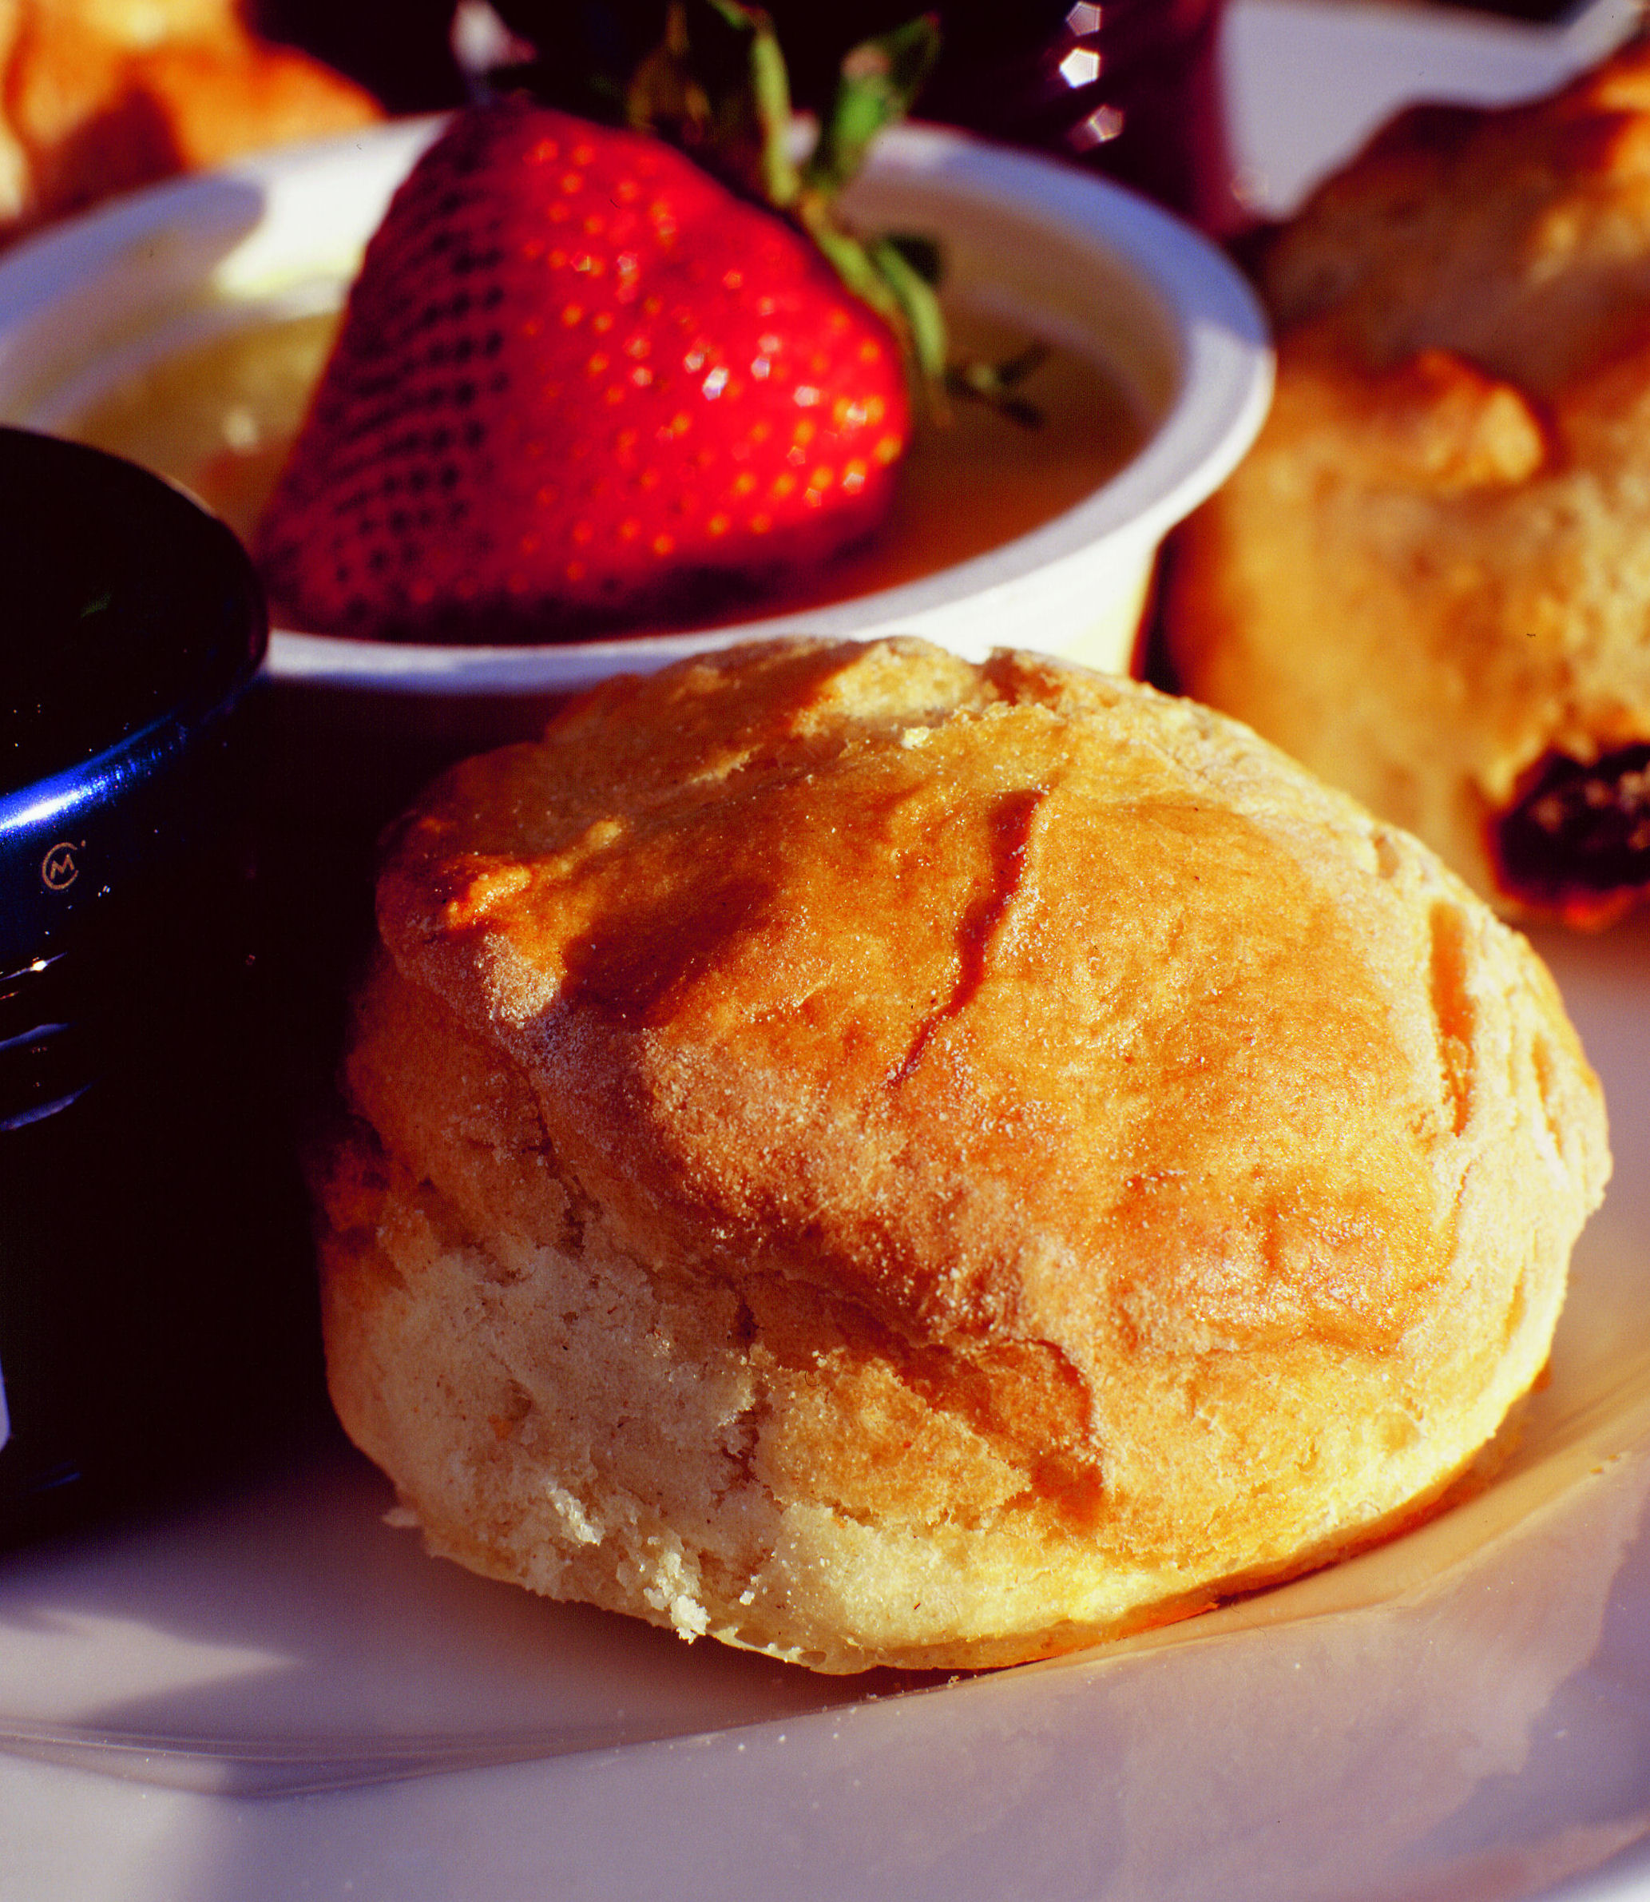
Morning Coffee Time required…………number.…… (served between 10.30-11.30am)

Coffee or Tea served with a freshly baked cookie………... £2.75 per person
Coffee or Tea served with a Danish pastry ………………….£4.50 per person
Coffee or Tea served with a bacon roll …………………….. £5.50 per person

Lunch Time required …………number…… (served between 12 noon - 2.30pm)

£13.95 per person
(Please choose one option for your whole group, except for vegetarians.)

Hunters Chicken, New Potatoes & Seasonal Vegetables………
OR Steak & Mushroom Suet Pudding, Mashed Potatoes & Seasonal Vegetables……….
OR Spinach and Ricotta Cannelloni with Mixed Seasonal Leaves (V)…………

Lemon Tart with Berry Compote …………
OR Chocolate & Cherry Brownie with Vanilla Ice Cream………
OR Fresh Fruit Salad with Cream ……..
and Tea or Coffee

£15.75 per person if a starter added - Soup & Roll…… or Pea & Ham Tartlet………
Lighter options are available on request. Please don’t hesitate to contact our Garden Restaurant Manager directly on 01892 871052 who will be pleased to help you with your selection.

Afternoon Tea Time required………..(after 3.00pm) Number……..

£5.20 per person
Penshurst Place Cream Tea consisting of 2 fruit scones with clotted cream & jam,
Served with Tea or Coffee………………
OR
£9.50 per person
Penshurst Place High Tea consisting of freshly made finger sandwiches, Lady De L’Isle’s apple cake,
a fruit scone with clotted cream & jam. Served with Tea or Coffee…………….

All menus are subject to availability. Full menus are available daily from the Garden Restaurant. Some of the foods on our menus may contain nuts and other allergens.
Please return this form to: Head of Visitor Services
Penshurst Place & Gardens, Penshurst, Tonbridge, Kent Tn11 8dg | Tel: 01892 870307 | Fax: 01892 870866 Email: wendyw@penshurstplace.com | Website: www.penshurstplace.com

