How to make a feeding frog.
You will need:
- Our feeding frog template
- One toilet roll tube
- Colouring pens, paints, or green paper
- A length of string
- A stapler

- Glue or staple a strip of green paper to a cardboard tube. You might need to trim it to size with a pair of scissors.
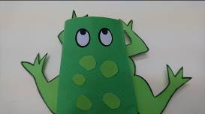
- Cut out the template for the frog’s legs and glue or stick it to the underneath of the body.
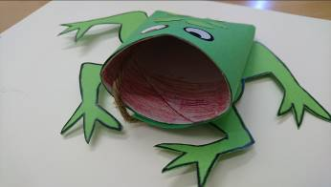
- Draw eyes on the top of the body and colour inside of the top end of the tube for the mouth.

- If you want, you can draw some dots on the back of the body or cut out some dots and glue them on.
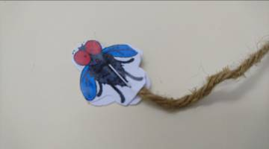
- Cut out the fly shapes and glue them together with one end of the string glued or stapled between them.
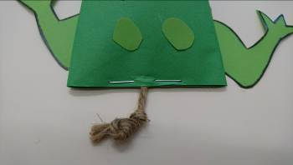
- Tie a knot at the other end of the string and put this through the tube so that it comes out of the back of the frog.

- Squeeze the tube together at the back of the frog and put in two staples, one either side of the string so that the string won’t pull right through the tube.
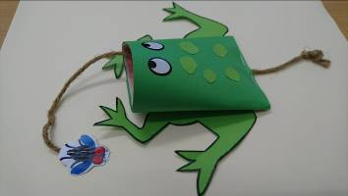

- Now put your frog on the table, carefully pull the knotted end of the string and watch the frog eat the fly!

