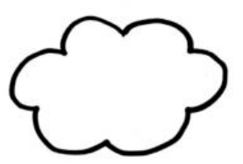
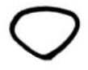
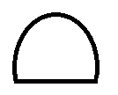

Relaxed Rabbit Template 2
Ears
Nose
Tail
Feet
Why not use this space to practice with the colours you want to use!

