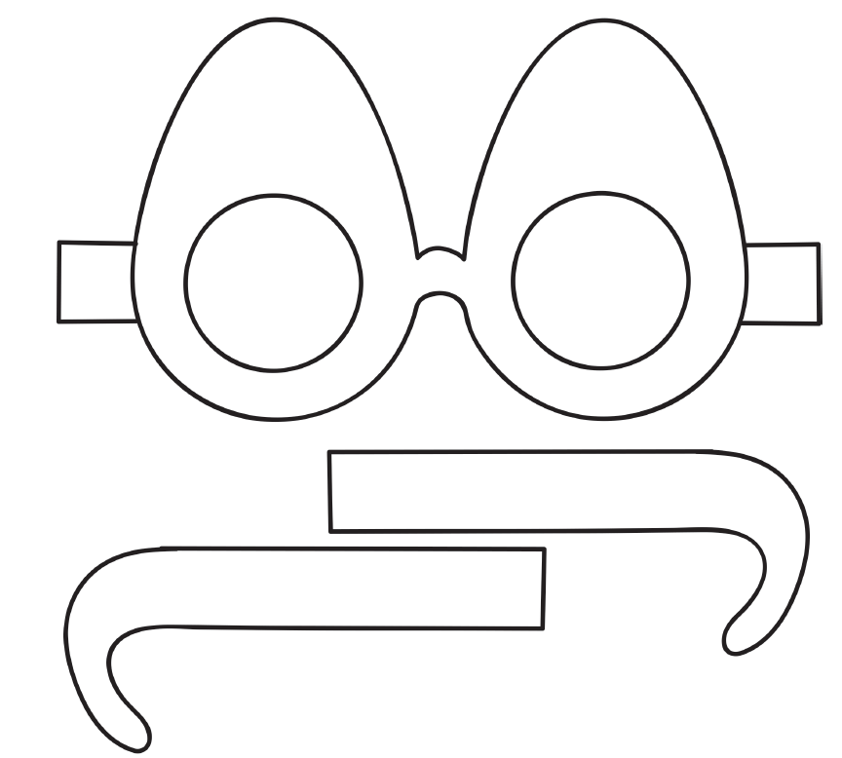
Egg-stra Special Spectacles!

