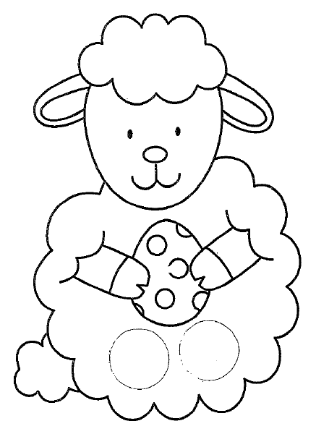
Leaping Lamb Finger Puppet
Colour your lamb and cut it out. Cut out the two circles at the bottom - you can start them off by using a hole punch.
Put your index and middle fingers through the holes and make your lamp leap!
Leaping Lamb Finger Puppet
Colour your lamb and cut it out. Cut out the two circles at the bottom - you can start them off by using a hole punch.
Put your index and middle fingers through the holes and make your lamp leap!
Leaping Lamb Finger Puppet
Colour your lamb and cut it out. Cut out the two circles at the bottom - you can start them off by using a hole punch.
Put your index and middle fingers through the holes and make your lamp leap!

