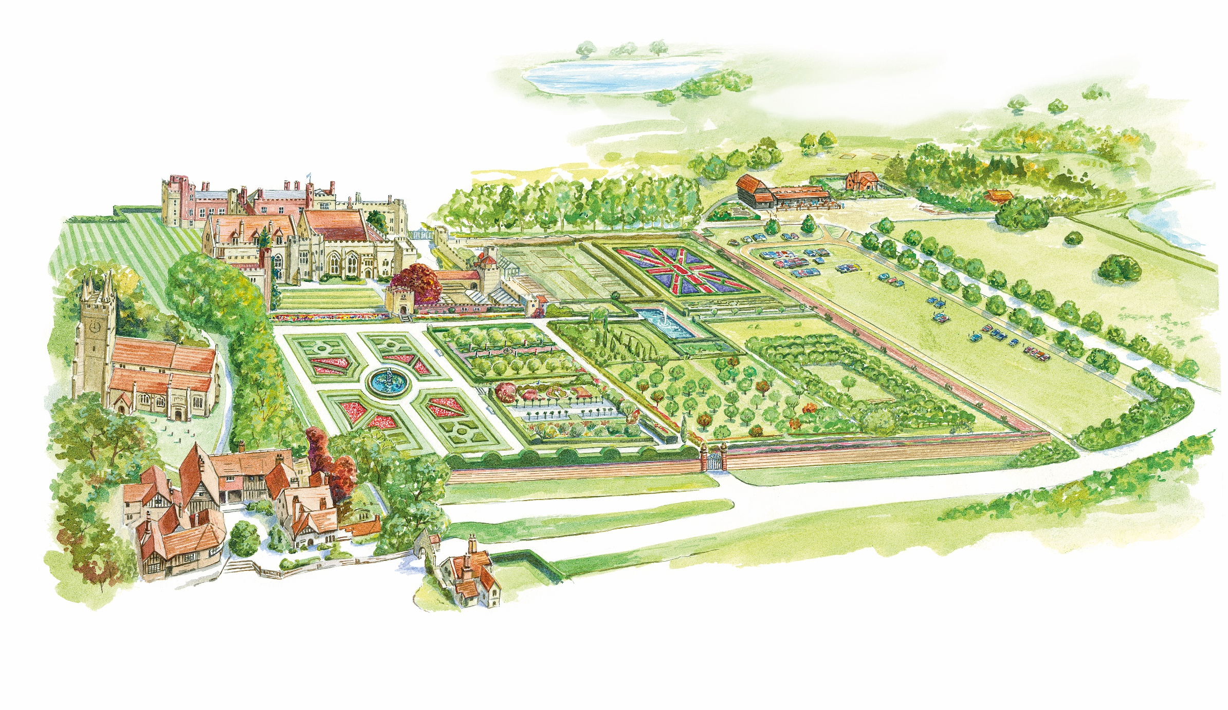

Please be reminded that the following facilities are closed:

* Adventure Playground
* Woodland Trail
* House
* Stable Yard Toilets
* Gift Shop
* Garden Restaurant
* Toy Museum

**Benches**

**Accessible Toilet and Nappy Changing Area**

**Available toilets**

**Hand Sanitiser Station**