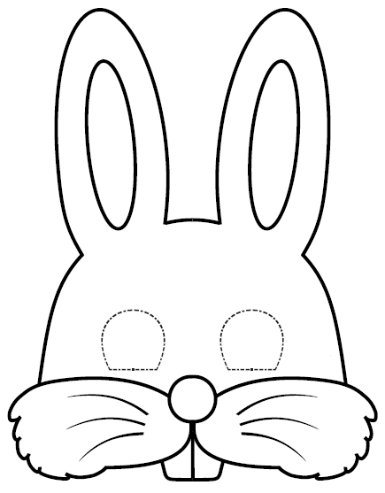
Colour your rabbit and cut along the outline - then cut out along the dotted lines around the eyes! You may need to ask for an adult’s help with the eyes as the easiest way to cut them out is to gently bend the card across the circle and make a tiny cut. This can then be used to put the scissor blade through to cut out the whole circle. To make a stick, cut this strip off at the dotted line and fold it lengthways as many times as you can (probably about 5 times) and sellotape it together. Glue or sellotape the stick to the back of the mask, making sure it runs at least halfway up the mask, to help keep it rigid. Hold the mask in front of your face and have a hoppy Easter!

