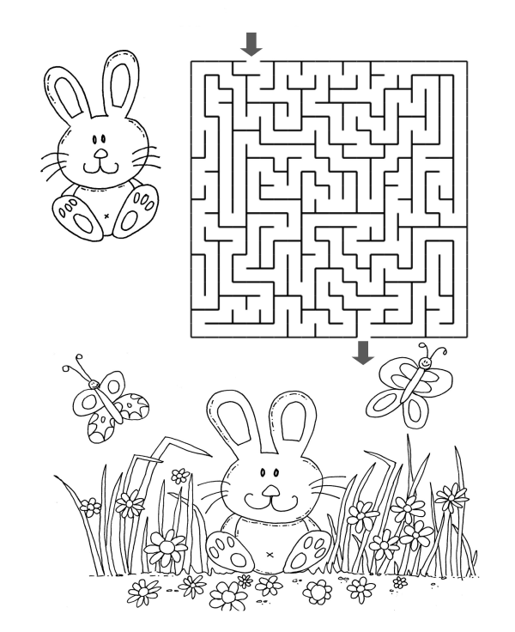
Help the rabbit to find its way through the warren to join its friend in the field!

